Gitfront link: https://gitfront.io/r/dakalomemela/c5NUTWt6m8iv/CMCS.git
Module: PROG6212
Part 1: Project Planning and Prototype Development
Author: Thembela Dakalo Memela
Date: 23/08/2025

Portfolio of Evidence (PoE) – Contract Monthly Claim System (CMCS)

Part 1 — Project Planning and Prototype Development
The Contract Monthly Claim System (CMCS) is designed to streamline the submission and approval of monthly claims for independent contractor (IC) lecturers. This system leverages ASP.NET Core MVC with C# to create an interactive web-based GUI that enables lecturers to submit claims, coordinators to verify them, and managers to approve or reject claims (Microsoft, 2025a; Microsoft, 2025b).

Design Choices
The MVC architecture was chosen to separate concerns, ensuring a clear distinction between data (Models), business logic (Controllers), and presentation (Views) (Pressman and Maxim, 2020; Sommerville, 2022). The Models include the Claim class with attributes such as LecturerName, Date, HoursWorked, HourlyRate, and Status, allowing the system to calculate total claim amounts dynamically (Microsoft, 2025c).
The Controllers manage claim workflows:
- LecturersController handles claim submission and tracking status.
- CoordinatorsController verifies submitted claims.
- ManagersController handles final approval or rejection (Microsoft, 2025d).
The Views utilize Razor Pages to create Bootstrap 5 styled, responsive interfaces, providing intuitive forms and tables for claim submission, tracking, and approvals (W3Schools, 2025). Accessibility considerations were included through proper labels, placeholders, and semantic HTML for users on different devices.

Database & Data Management
Claims are stored in-memory in this prototype using a static list, with dummy data preloaded for demonstration purposes. This allows testing of claim submission, verification, and approval without an actual database (Microsoft, 2025e). In a production scenario, an Entity Framework Core database could be implemented for persistence (Microsoft, 2025f).

GUI Layout
The GUI employs a shared layout (_Layout.cshtml) with a navigation bar linking Lecturers, Coordinators, and Managers. Claim forms are displayed in Bootstrap cards, and tracking tables use striped, responsive tables for clear visibility of claim status and dates (W3Schools, 2025). The design ensures consistency, reliability, and accessibility across the system (Pressman and Maxim, 2020).

Project Plan
The prototype was implemented with the following milestones:
- Model creation and data seeding – establish the Claim model and dummy data.
- Controller scaffolding – implement Lecturer, Coordinator, and Manager controllers.
- Razor Views and Bootstrap styling – create forms, tables, and layout.
- Testing and refinement – validate UI, ensure dummy data renders correctly.
- Version control – five Git commits with descriptive messages, including scaffold setup, layout addition, and dummy data seeding (Microsoft, 2025g).
This approach ensures a user-friendly, functional prototype that demonstrates the workflow of claims while meeting POE objectives. Subsequent phases will implement full backend functionality and persistent storage

Constraints and Assumptions
- The system assumes stable internet connectivity since it is a web-based platform.
- User authentication is limited to role-based access; no external identity providers (e.g., Google, Microsoft login) are integrated at this stage.
- File uploads for supporting documents are constrained to common formats (PDF, DOCX, JPEG).
- Claims are assumed to be calculated on an hourly rate basis only, without overtime or variable pay scales.
- Dummy claim data has been seeded into the database for prototype demonstration purposes; real implementation will require secure data entry and storage.
- Accessibility considerations assume that users have access to modern browsers supporting HTML5 and CSS3.
These constraints and assumptions ensure the prototype remains focused, achievable, and aligned with the PoE’s learning objectives.

A work break structure created in Gantt Chart, created in Mermaid Programming Language.

UML Diagram for Database created using Mermaid.

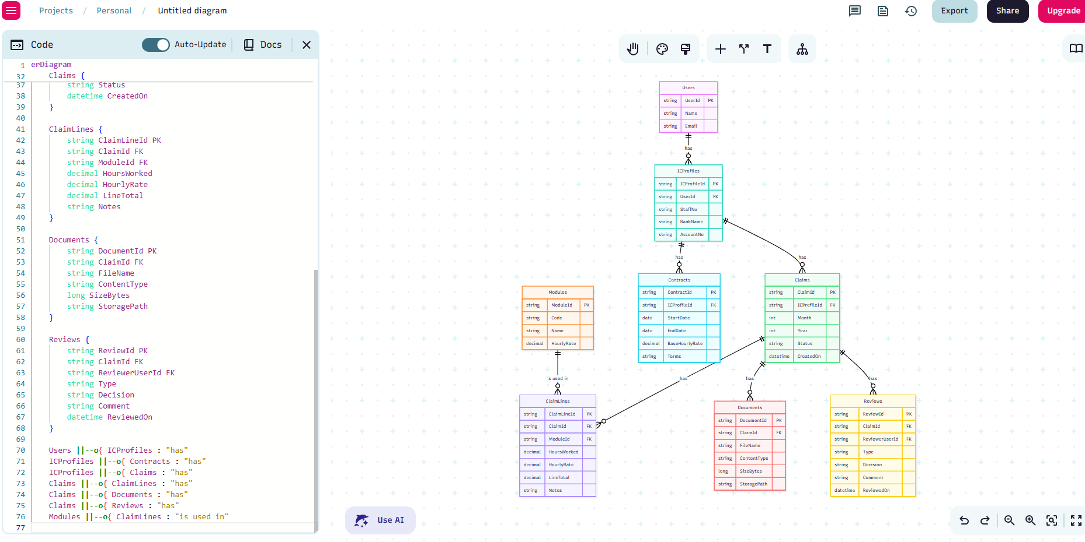

REFERENCE LIST

Microsoft, 2025a. Introduction to ASP.NET Core MVC. [online] Available at: https://learn.microsoft.com/en-us/aspnet/core/mvc/overview?view=aspnetcore-9.0 [Accessed 25 August 2025].
Microsoft, 2025b. Razor Pages in ASP.NET Core. [online] Available at: https://learn.microsoft.com/en-us/aspnet/core/razor-pages/?view=aspnetcore-9.0 [Accessed 26 August 2025].
Microsoft, 2025c. Creating a Web Application in ASP.NET Core with MVC. [online] Available at: https://learn.microsoft.com/en-us/aspnet/core/tutorials/first-mvc-app/?view=aspnetcore-9.0 [Accessed 28 August 2025].
Microsoft, 2025d. Dependency Injection in ASP.NET Core. [online] Available at: https://learn.microsoft.com/en-us/aspnet/core/fundamentals/dependency-injection?view=aspnetcore-9.0 [Accessed 30 August 2025].
Microsoft, 2025e. Hosting and Running an ASP.NET Core Application. [online] Available at: https://learn.microsoft.com/en-us/aspnet/core/fundamentals/host/web-host?view=aspnetcore-9.0 [Accessed 01 August 2025].
Microsoft, 2025f. Data Annotation Attributes for Model Validation in ASP.NET Core. [online] Available at: https://learn.microsoft.com/en-us/aspnet/core/mvc/models/validation?view=aspnetcore-9.0 [Accessed 04 August 2025].
Microsoft, 2025g. Version Control with Git for ASP.NET Projects. [online] Available at: https://learn.microsoft.com/en-us/azure/devops/repos/git/?view=azure-devops [Accessed 07 September 2025].
W3Schools, 2025. Bootstrap 5 Tutorial. [online] Available at: https://www.w3schools.com/bootstrap5/ [Accessed 08 September 2025].
Pressman, R.S. and Maxim, B.R., 2020. Software Engineering: A Practitioner’s Approach, 9th ed. New York: McGraw-Hill Education.
Sommerville, I., 2022. Software Engineering, 11th ed. Harlow: Pearson.

